Annex 6: Data Management and Quality Control

BetterInfo data was collected using Open Data Kit (ODK), a suite of free, open source tools that allows data collection using Android devices and submission to a server. ODK has great features such as the ability for data to be uploaded as it is collected with error checking mechanism embedded into the collection forms. However, ODK has limitations. Below, we discuss some of the limitations and some remedies.

As far as we are aware, ODK does not support table relationships in form of primary and secondary keys. For most participants in BetterInfo study, two forms were administered, each at different times and therefore submitted independently. The challenge then was to ensure that participant IDs in one form matched those in the other in the absence of primary and secondary keys. Our strategy was to ensure that the participant IDs were entered correctly in both tables, which aided in reasonably accurate matching. To do this, we embedded a list of all study IDs underneath all study ID entry fields such that all entries in these fields were validated against this list. This ensured that data entrants selected the participant IDs rather than have the IDs being entered manually. Manual entry was prone to typographic errors (typos) and thereby mismatches between forms as we noted in the pilot study.

For our data quality assurance and reporting, we used Stata and Excel. To ensure accuracy of data, we generated a list of data inconsistencies (see Table 1 under appendix below), which were sent back to the data collection teams through the QA/QC Data Supervisors. Once every two weeks, the list of inconsistencies was generated and sent to respective trackers. We thought two-week intervals was short enough for respective data collectors to recall many details of recently concluded interviews. We built an error resolution template in excel, which was pre-populated with error details, response fields along with the record unique identifier (uuid) by which we could match responses to respective database records. Additional fields had pre-programmed Stata code, which incorporated these resolutions into standard Stata do file code.

We maintained a 'master do file' of all resolutions which we could ran at any time to create a cleaned dataset without having to temper with the server data. The 'do file' was updated every time we received query resolutions from the data collectors. Also, prior to generating a new list of errors, we ran this ‘do file’ to ensure previously resolved errors were excluded.

The error resolution template as well as study progress reports were created using Stata’s “putexcel” function to populate a pre-designed excel template.

Appendix

The three lines of Stata code below populated the “Paper Tracking” section on the progress report columns E to J rows 9 to 21 (Figure 1 below)

tab clinic why_tracking_not_possible, matcell(A)
matrix M1 = A[1..14, 1..6] /// selects the 6 by 14 matrix representing Lusaka Clinics in order from Bauleni to Railway Clinic
putexcel E9=matrix(M1) using "reportingTemplate.xlsx", sheet("Paper Tracking") modify /// This outputs the matrix M1 into the cells E9 to J21 starting at E9

Table 1: Excerpt of report showing values populated by the matrix M1
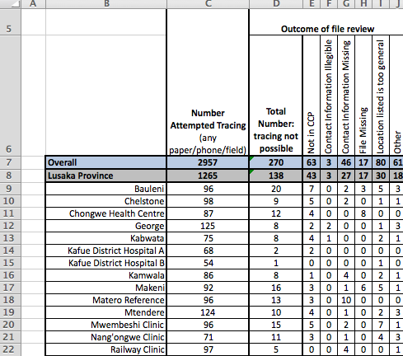

List of data inconsistencies
1. Duplicate Module A
2. Enrolment (A7) after date form completed (A2)
3. Enrolment (A7) after date last seen in clinic (A8)
4. Enrolment (A7) after date scheduled to return for clinical review (A10)
5. Enrolment (A7) after date of transfer (A15_transfer)
6. Enrolment (A7) after date of death (A15_died)
7. Date last seen in clinic (A8) after date scheduled to return for clinical review (A10)
8. Date last seen in clinic (A8) after date of transfer (A15_transfer)
9. Year last seen (A8) after year of death (A15_year_died)
10. Date of death (A15_date_died) after date form completed (A2)
11. Date last seen in clinic (A8) after date form completed (A2)
12. Transfer (A15_transfer) after form completion (A2)
13. A8 differs from A15(date of last visit)
14. Patient Not lost (A15), yet Date last seen in clinic (A8) before or same as last SmartCare visit (From Tracking List)"
15. Reason tracking not possible missing (A14)"
16. Last visit date missing (A15)"
17. Transfer date missing (A15)
18. Date of death missing (A15)
19. Specify other reason why tracking not possible (A14_Other_Specify)
20. ID not on tracking list
21. Patient Not in CCP (A14) was selected, yet Date last seen in clinic (A8) is within CCP (1Aug2013-31July2015)
22. Form completed (A2) before scheduled return date(A10) but tracking to be attempted (A13)"
30. Module B without corresponding A
31. Module A without corresponding B (a week after submitting A)
32. Module A says tracking no longer needed or not possible (A13) but Module B completed
33. Last visit date in Module A (A8) differs from that in B (B.0.6): ALSO UPDATE CORRESPONDING APPOINTMENT DATE
34. Last visit date (B.0.6) is after patient interview date (B.1.3)
35. Last visit date (B.0.6) is after informant interview date (B.2.3)
36. Last contact with patient (B.2.6.A) after informant interview date (B.2.3)
37. Informant date of death (B.2.6.C) after interview date (B.2.3)
38. Registry date of death (B.3.2) before last visit date (B.0.6)
39. Date last took ARVs (B1.8.C) before date of ART start (B1.7.A)
40. ART start (B1.7.A) is after last visit at original clinic (B1.5.A) yet patient has not enrolled elsewhere or been back after last recorded visit (B1.5)
41. Pre ART at original clinic (B.0.7), has not enrolled at new clinic nor returned at old (B1.5) yet has art start date (B1.7.A)"
42. Pre ART at original clinic (B.0.7) but ART start (B1.7.A) before last visit at original clinic (B1.5.A)"
43. ART start (B1.7.A) is after last visit at new clinic (B1.5.B)"
44. Patient interview date (B1.3) before date of last clinic visit(reported by patient) (B1.5.A)
45. Initial visit at new clinic (B1.5.C) is after most recent visit at new clinic (B1.5.B)
46. Initial visit at new clinic (B1.5.C) is before last visit at original clinic (B.0.6)
47. Field tracking required
48. Spent no time (B.4.4, B.4.5) yet communicated with informant (Section B1) or patient (Section B2)
49. Interview by phone (B1.2 or B.2.2) but in person time >0 (B.4.5)
50. Interview in person (B1.2 or B.2.2) but phone time >0 (B.4.4)
51. Art Status in A different from status in B"

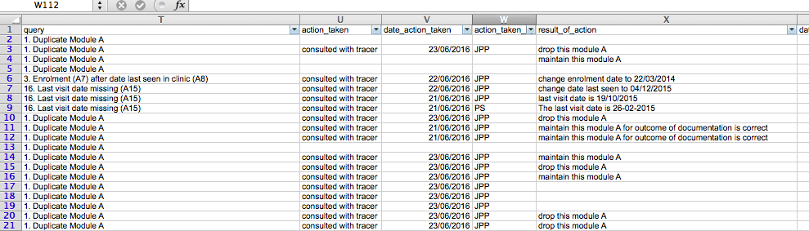
Figure 1: Excerpt from error report showing error type and resolution

